1.compare two JSON have same properties without order

var obj1={name:"person1",age:5}

var obj2={age:5,name:"person1"}

var key1=Object.keys(obj1)

var key2=Object.keys(obj2)

function areObjectEqual(obj1,obj2)

{

  if(key1.length !== key2.length)

  {return false}

  for( var key of key1)

  {if(obj1[key]!==obj2[key])

  {return false}

  }

  return true

}

console.log(areObjectEqual(obj1,obj2))

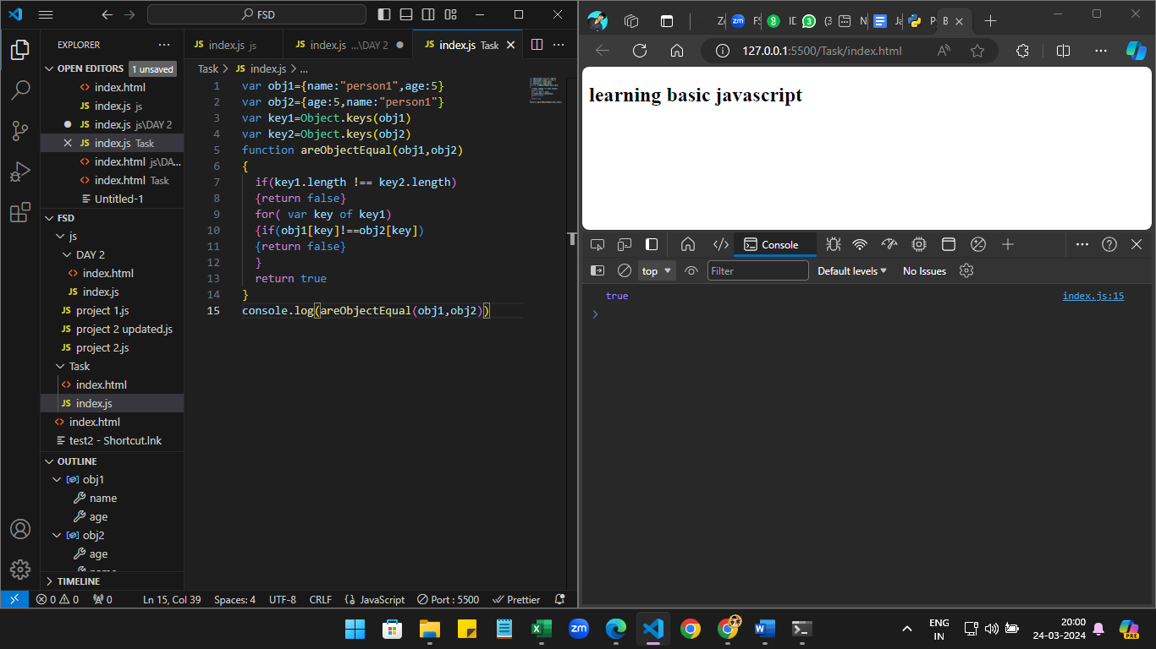

2.Display country flag in console

a)

var xhr= new XMLHttpRequest()

xhr.open("GET","https://restcountries.com/v3.1/all",true)

xhr.onload=function()

{

    var countries=JSON.parse(xhr.responseText)

    countries.forEach((country) => {

      console.log(country.name.common + ":" +country.flag)

    })

}

xhr.send()

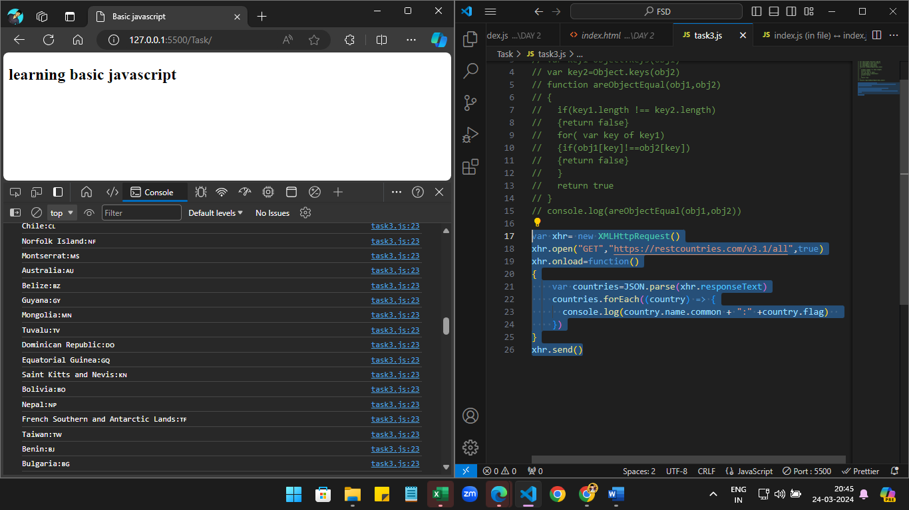

b) Display countries,region,subregion and population in console

var xhr= new XMLHttpRequest()

xhr.open("GET","https://restcountries.com/v3.1/all",true)

xhr.onload=function()

{

    var countries=JSON.parse(xhr.responseText)

    countries.forEach((country) => {

      console.log(country.name.common + ":" +country.region+

      ":"+country.subregion+":"+country.population)

    })

}

xhr.send()

